Aigle – St Maurice

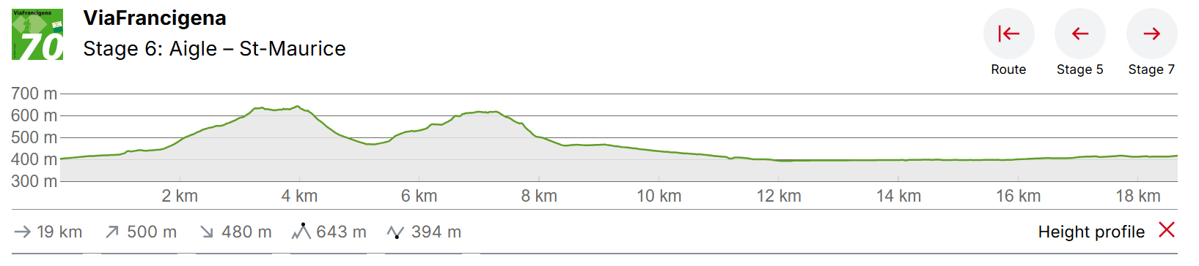The route leaves Aigle via the vineyard, reaches Gryonne and later the Rhone, which it crosses at Massongex, the ancient capital of Celtic Valais. Once in St. Maurice, the pilgrim has already covered exactly half the distance from Canterbury to Rome.
After a short stretch of forest, you reach the next vineyards around Ollon in about one and a half hours. The hike is uphill for a while, then proceeds downwards again to Antagnes. There is an incredible view across the Rhone Valley and the surrounding mountains. At the Gryonne river, you are almost halfway through the hike and you have covered most of the altitude difference.
You follow the river until just before it flows into the Rhone, which you cross a little later to arrive in Massongex. The village was the capital of Celtic Valais long ago. Now comes the final hour of the hike to the end of this stage in St. Maurice. Pilgrims walking all the way from Canterbury to Rome are now right in the middle of the route. Shortly before St. Maurice you pass the fairy grotto. The water has worn away the rock here for thousands of years, creating a grotto with a small underground lake and waterfall.
Accomodations:
Auberge de Jeunesse Montreux
Pass. de l'Auberge 8, 1820 Montreux, Switzerland
18 min train (R2) to Aigle from Territet

Hotel Du Nord – (approx. 100 CHF PPPN (200/double room)
R. Colomb 2-4, 1860 Aigle, Switzerland

Leysin – R70 train 30 min to Aigle -0700, 0740

Résidence Castel Club Leysin Parc - approx. 50 CHF PPPN (dependent on sharing)
Route de Collonges 10, 1854 Leysin, Switzerland

Résidences du Chamossaire – Approx. 100 CHF Per double bed
Route du Chamossaire 1-3, 1854 Leysin, Switzerland

Arrival
Aigle is approx.. 2 h by public transport from Geneva airport

St Maurice accom.
Abbaye de Saint-Maurice – 35 CHF PP
Porter’s Lodge (Reception), Avenue d’Agaune 15, 1890 Saint-Maurice
